


AWS FIRST CLOUD AI JOURNEY - PROJECT PLAN

Project Name:
ACADEMIC RESEARCH CHATBOT
Project team | : ARC Team
Education | : FPT University HCM Campus

Ho Chi Minh City, December 09, 2025
TABLE OF CONTENTS
PART 1. BACKGROUND AND MOTIVATION 4
1.1. Executive Summary 4
1.2. Project Success Criteria 4
1.3. Assumptions 4
PART 2. SOLUTION ARCHITECTURE / ARCHITECTURAL DIAGRAM 6
2.1. Technical Architecture Diagram 6
2.2. Technical plan 7
2.3. Project Plan 11
2.4. Security Considerations 12
PART 3. ACTIVITIES AND DELIVERABLES 13
3.1. Activities and Deliverables 13
3.2. Out of scope 15
3.3. Path to production 16
PART 4. EXPECTED AWS COST BREAKDOWN BY SERVICES 18
4.1. Compute services 18
4.2. AI/ML services (Bedrock) 18
4.3. Storage services 19
4.4. Networking & CDN 19
4.5. Application services 19
4.6. Monitoring & Management 20
4.7. Total cost summary 20
PART 5. TEAM MEMBER EVALUATION 21
PART 6. ACCEPTANCE 23

PART 1. BACKGROUND AND MOTIVATION

1.1. Executive Summary
Academic Research Chatbot is an AI assistant supporting academic research, helping students and lecturers search, summarize, and analyze scientific documents (PDFs, papers) through natural conversation with accurate source citations.
Key Highlights:
- Core Technology: Combines IDP (Amazon Textract) to process documents (including scans) and RAG (Amazon Bedrock - Claude 3.5 Sonnet) to generate intelligent responses.
- Optimized Architecture: Hybrid model using 1 EC2 t3.small combined with Serverless services (Amplify, Cognito, S3, DynamoDB) to balance performance and cost.
- Feasibility: Serves ~50 internal users with operating costs ~$60/month, fast deployment time (20 days), and maximizes AWS Free Tier.

1.2. Project Success Criteria
Current Problem Students and researchers have to work with a large number of academic documents (conference papers, journals, theses, technical reports). Many documents are old scanned PDFs (pre-2000), without a text layer, making searching for content, data, and tables very time-consuming. Public AI tools (ChatGPT, Perplexity, NotebookLM, etc.) are not directly connected to the school/department’s internal document repository, making it difficult to ensure security and access rights by subject or research group. The current infrastructure lacks a unified access point to:
- Manage research documents by subject/topic.
- Allow researchers to ask questions directly on their own papers.
- Ensure the answers have clear citations (paper, page, table, section). Consequence: Researchers have to manually read, take notes, and copy data from multiple papers; lecturers find it difficult to quickly synthesize information when preparing lectures or topics; academic data is scattered across many personal machines, difficult to standardize and reuse.

1.3. Assumptions
Solution Academic Research Chatbot proposes building an internal academic Q&A platform based on AWS, where:
1. Dev/Admin loads research document repository:
- Upload PDFs to Amazon S3, metadata is stored in Amazon DynamoDB.
- An EC2 worker consumes the Amazon SQS queue, calls Amazon Textract to OCR, extract text, tables, forms, including scanned documents.
- Worker normalizes/chunks content, sends to Amazon Bedrock Titan Text Embeddings v2 to generate embeddings, and indexes into Qdrant on EC2.
2. Researchers ask questions via web interface (Amplify + CloudFront):
- Questions are embedded, querying Qdrant to retrieve the most relevant segments (Retrieval).
- These segments are passed to Claude 3.5 Sonnet on Amazon Bedrock to generate answers with accurate citations (paper, page, section, table) and explanations in academic context. All access is protected by Amazon Cognito (researcher vs admin authorization), logs & metrics are monitored via Amazon CloudWatch + SNS (alerts on worker errors, queue backlog, high EC2 CPU).
Benefits and ROI Academic Efficiency:
- Reduces 40–60% of time researchers spend finding data, F1-scores, p-values, sample sizes, experimental equipment, or method descriptions from multiple papers.
- Reduces citation errors due to forgetting pages/tables, as the chatbot always returns sources and locations. Internal Knowledge Management:
- Research documents are centralized in an S3 + DynamoDB repository, easy to backup, authorize, and expand.
- Can be reused for many courses, topics, and labs without building a new system. Low & Controllable Infrastructure Costs:
- Hybrid model 1 EC2 + managed AI services keeps operating costs for 50 internal users at around < $50/month, mainly paying for EC2, 2–3 VPC endpoint interfaces, and Bedrock/Textract usage.
- The system is designed to be deployed in about 20 days by a team of 4, suitable for a research/internship project but still has product architecture quality. Long-term Value:
- Creates a platform to later integrate learning behavior analysis dashboards, paper recommendation modules, or expand to multi-language and multi-field learning assistants.

PART 2. SOLUTION ARCHITECTURE / ARCHITECTURAL DIAGRAM

2.1. Technical Architecture Diagram
Academic Research Chatbot applies the AWS Hybrid RAG Architecture model with IDP (Intelligent Document Processing), combining a single EC2 (FastAPI + Qdrant + Worker) with managed AI services (Textract, Bedrock) to optimize costs while ensuring performance for about 50 internal users.
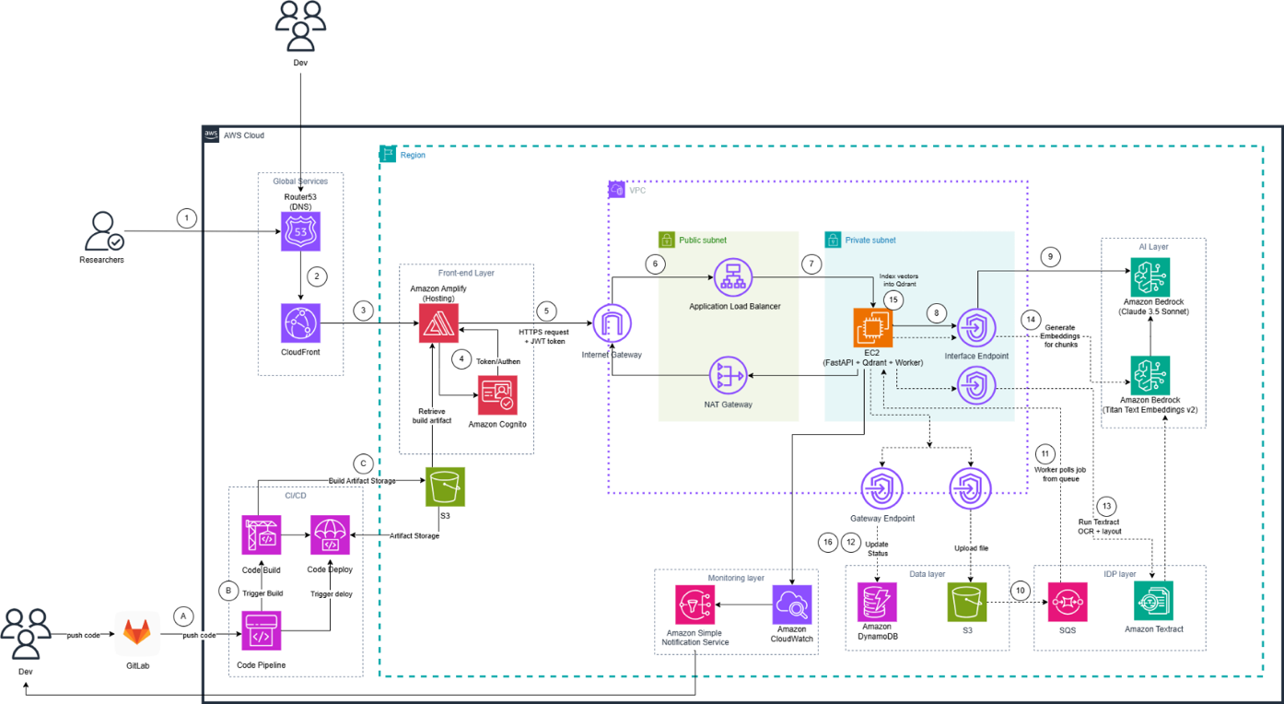
Figure 2. 1. Data Processing and Conversation Flow

AWS Services Used:
- Amazon Route 53: DNS management for chatbot platform domain.
- Amazon CloudFront: CDN distributing web interface (chat + admin) with low latency.
- AWS Amplify Hosting: Hosts web application (React/Next) for Researchers and Dev/Admin.
- Amazon Cognito: User authentication, researcher vs admin role management.
- Amazon S3: Stores original PDF files uploaded by Dev/Admin (raw documents).
- Amazon SQS (doc_ingestion_queue): Job queue for document processing.
- Amazon Textract: IDP/OCR for scanned PDFs and digital PDFs.
- Amazon Bedrock:
- Titan Text Embeddings v2: Generates embedding vectors for text chunks.
- Claude 3.5 Sonnet: Generates academic answers from context + user questions (RAG).
- Amazon DynamoDB: Documents table: document metadata, pipeline status (UPLOADED, IDP_RUNNING, EMBEDDING_DONE, FAILED).
- Amazon EC2 (t3.small, private subnet):
  - Runs FastAPI backend (REST API for chat and admin).
  - Runs Qdrant Vector DB to store and query embeddings.
  - Runs Worker process consuming SQS, calling Textract + Titan, indexing into Qdrant, updating DynamoDB.
- VPC + ALB + VPC Endpoints:
- VPC + private subnet for EC2 (not directly exposed to Internet).
- Application Load Balancer (ALB): entry point for all APIs from Amplify to EC2.
- Gateway Endpoint (S3, DynamoDB) and Interface Endpoint (Textract, Bedrock, SQS – if used) for EC2 to call AWS services without NAT Gateway.
- Amazon CloudWatch + Amazon SNS:
- Collects logs and metrics from EC2, ALB, SQS.
- CloudWatch Alarms send alerts via SNS when CPU is high, SQS backlog, worker errors, etc.
- AWS CodePipeline/ CodeBuild: Automates build & deploy for backend (FastAPI on EC2).

2.2. Technical plan
Project Overview:
Type: AWS Internship Project
Team: 4 interns (Tech Lead, Backend+IDP, Frontend, DevOps)
Timeline: 20 days
Budget: ~$60/month
Users: 50 researchers
Documents: 750 academic papers
Architecture:
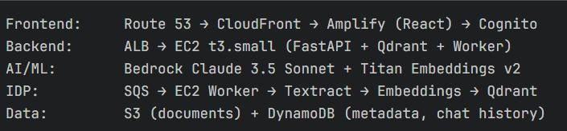

Project Structure:
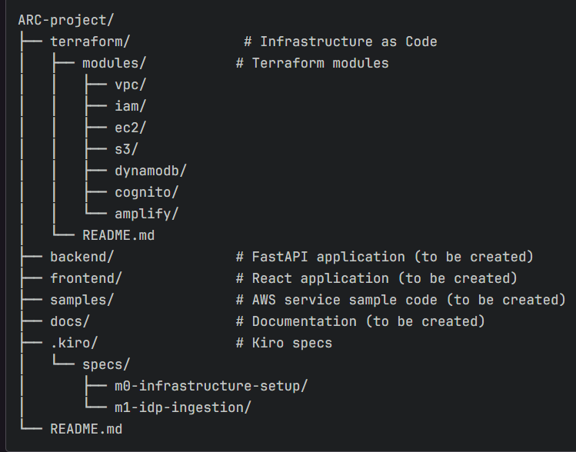
ARC Chatbot - Terraform Infrastructure:
This directory contains Terraform configuration for provisioning AWS infrastructure for the Academic Research Chatbot project.
Prerequisites:
- Terraform >= 1.0
- AWS CLI configured with appropriate credentials
- AWS Account with necessary permissions
- Infrastructure Components
- VPC: Virtual Private Cloud with public and private subnets
- EC2: t3.small instance running FastAPI and Qdrant
- S3: Document storage bucket
- DynamoDB: DocumentMetadata and ChatHistory tables
- Cognito: User authentication with admin and researcher groups
- Amplify: React frontend hosting
- IAM: Roles and policies for EC2 and team members
- ALB: Application Load Balancer for EC2 access
- VPC Endpoints: Gateway (S3, DynamoDB) and Interface (Bedrock, Textract)
Directory Structure:
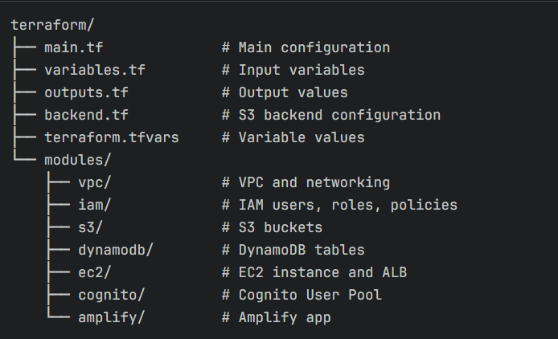
Setup Instructions:
1. Initialize Backend (First Time Only)
Before running Terraform, create the S3 bucket and DynamoDB table for state management:
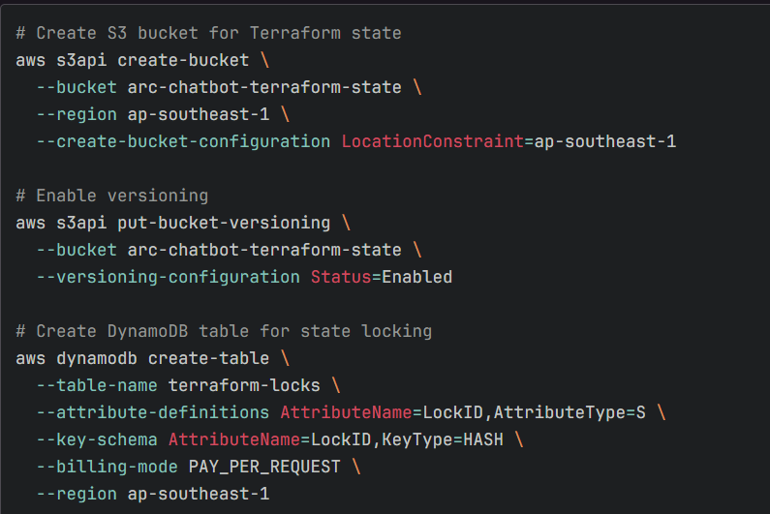
2.Initialize Terraform:
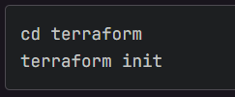
3.Review Configuration:
Edit terraform.tfvars if needed:
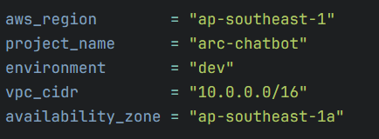
4.Validate Configuration:
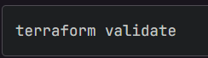
5.Plan Deployment:
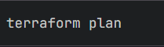
6.Apply Configuration:
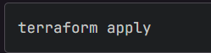
7.View Outputs:
After successful deployment:
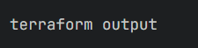
Important outputs:
- alb_dns_name: URL to access the API
- cognito_user_pool_id: For frontend configuration
- cognito_app_client_id: For frontend configuration
- documents_bucket_name: S3 bucket for uploads

2.3. Project Plan
The project is executed over approximately 6 weeks with specific phases:
- Week 1-2 (Days 1-10): Research & Design
- Detailed architecture design, scope definition, service selection. Planning for operational cost optimization and deployment.
- Week 3 (Days 11-15): AWS Infrastructure Setup
- Configure VPC, Subnets, Security Groups, IAM Roles.
- Deploy EC2 t3.small, S3 bucket, DynamoDB tables.
- Setup VPC Endpoints (Gateway + Interface).
- Week 4 (Days 16-20): Backend APIs & IDP Pipeline
- Build FastAPI endpoints (/api/chat, /api/admin/upload).
- Integrate IDP pipeline: SQS → Worker → Textract → Embeddings → Qdrant.
- Connect Bedrock (Titan Embeddings + Claude 3.5 Sonnet).
- Week 5 (Days 21-25): Testing & Error Handling
- End-to-end testing with a set of ~50-100 papers.
- Handle edge cases, retry logic, error handling.
- Optimize chunking strategy and retrieval accuracy.
- Week 6 (Days 26-30): Deployment & Documentation
- Finalize UI/UX for Admin and Researcher.
- Setup CloudWatch Alarms + SNS notifications.
- Prepare user guide and demo for the group of 50 researchers.

2.4. Security Considerations
- EC2 in private subnet
- S3 buckets with encryption and blocked public access
- IAM least-privilege policies
- Cognito for authentication
- VPC endpoints for AWS services
Security Notes:
- SSH Access: Restrict EC2 security group to specific IP ranges
- IAM Keys: Store access keys securely, rotate regularly
- S3 Buckets: Public access is blocked by default
- Cognito: Enable MFA for admin users
- VPC: EC2 in private subnet, no direct internet access

PART 3. ACTIVITIES AND DELIVERABLES

3.1. Activities and Deliverables
Project Phase | Timeline | Activities | Deliverables/Milestones | Total man-day
Assessment (M0) | 10/11 - 14/11 | Setup AWS Account, IAM Users & Policies• Study Bedrock Claude 3.5 & Cohere Embed APIs  Study Textract AnalyzeDocument API  Design architecture | AWS Account 427995028618 với IAM users• Sample code: test_bedrock.py, test_textract.py  Architecture diagram  Cost estimation (~$65/month) | 5 man-day
Setup base infrastructure (M0) | 10/11 – 14/11 | - Create VPC, Subnets, IGW, NAT Gateway  - Setup Terraform project structure  - Setup VPC Endpoints (S3, DynamoDB, Textract, Bedrock)  - Setup EC2 t3.small with Security Groups  - Install Docker, FastAPI on EC2  - Setup S3 buckets, DynamoDB tables  - Configure Cognito User Pools  - Setup ALB with health checks | - VPC vpc-072dfe1e9bfff9d20 (10.0.0.0/16)  - EC2 Instance i-028d43eb22d2919fe  - Terraform modules (61 resources)  - S3 bucket arc-chatbot-documents-427995028618  - DynamoDB tables (metadata, chat-history)  - Cognito User Pool ap-southeast-1_8KB4JyvsX  - ALB arc-chatbot-dev-alb | 8 man-day
Setup component 1: IDP Pipeline (M1) | 15/11 – 19/11 | - Create SQS queue for document processing  - Implement PDF detection (digital vs scanned)  - Implement PyPDF2 extraction for digital PDFs  - Implement Textract extraction for scanned PDFs  - Implement text chunking (1000 tokens, 200 overlap)  - Implement SQS Worker  - Setup Qdrant vector database on EC2  - Implement Cohere Embeddings (1024-dim)  - Create document status tracking  - Implement Admin Upload/List APIs  - Configure S3 event notification to SQS | - SQS Queue arc-chatbot-dev-document-processing  - PDF Detector service (17 tests passed)  - PDF Extractor service (30 tests passed)  - Text Chunker service (22 tests passed)  - SQS Worker service (20 tests passed)  - Qdrant collection documents (17 tests passed)  - Embedding service với Cohere v3 (17 tests passed)  - Document Status Manager (12 tests passed)  - Admin APIs: POST /upload, GET /documents | 10 man-day
Setup component 2: RAG Chat (M2) | 20/11 – 24/11 | - Implement vector search in Qdrant  - Implement Bedrock Claude 3.5 Sonnet integration  - Build RAG prompt template with citations  - Implement POST /api/chat endpoint  - Implement chat history storage• Add rate limiting for Claude AP  - Implement fallback to Claude Haiku  - Add error handling & retry logic | - Enhanced Qdrant search (35 tests passed)  - Claude Service với streaming (20 tests passed)  - RAG Service với 4 templates (19 tests passed)  - Chat API với SSE streaming (21 tests passed)  - Chat History Manager (15 tests passed)  - Rate Limiter: 60 RPM, 100K TPM (23 tests passed)  - Budget Manager: $10/day, $200/month (22 tests passed)  - Bedrock Retry với exponential backoff (35 tests passed) | 8 man-day
Testing & Golive(M3) | 25/11 – 29/11 | - Implement login page with Cognito  - Build chat interface UI  - Display citations with document links  - Build admin dashboard for upload  - Show document processing status  - Integration testing E2E | - AuthService với JWT validation  - ChatPage với message bubbles, citations  - CitationCard, DocumentViewerModal components  - AdminPage với drag-drop upload  - Real-time status monitoring (auto-refresh)  - Full-stack testing guide | 6 man-day
Handover | 30/11 | - Documentation  - Knowledge transfer  - Demo preparation | - README với setup instructions  - API contract documentation  - Demo script (7 phút)  - Infrastructure documentation | 3 man-day

3.2. Out of scope
- Multi-tenant support - Hệ thống hiện tại chỉ phục vụ 1 organization
- Advanced analytics dashboard - Không có báo cáo chi tiết về usage patterns
- Document versioning - Không hỗ trợ multiple versions của cùng 1 document
- Real-time collaboration - Không có tính năng share conversations giữa users
- Mobile application - Chỉ có web interface, không có native mobile app
- Multi-language UI - Frontend chỉ hỗ trợ tiếng Việt
- Advanced OCR for handwriting - Textract chỉ xử lý printed text, không hỗ trợ chữ viết tay
- Document editing/annotation - Users không thể edit hoặc annotate documents
- Offline mode - Yêu cầu internet connection để sử dụng
- Custom model fine-tuning - Sử dụng pre-trained models (Claude 3.5, Cohere Embed v3), không fine-tune
- Full CI/CD pipeline - CodePipeline/CodeBuild/CodeDeploy chưa hoàn thiện (Task #45, #46)
- Route 53 custom domain - Chưa setup domain riêng (Task #41)
- CloudWatch alarms - Chưa setup đầy đủ 4 alarms (Task #43)

3.3. Path to production
The POC is built with specific use cases: academic document search for 50 researchers with 750 documents. To deploy to production, the following need to be added:
- Security Enhancements
- Implement WAF (Web Application Firewall) cho ALB
- Enable VPC Flow Logs cho audit
- Encrypt data at rest với KMS customer-managed keys
- Implement secrets rotation cho credentials
- Tighten CORS policy (hiện tại allow_origins=["*"])
- Scalability
- Auto Scaling Group cho EC2 (hiện tại single instance - SPOF)
- Migrate Qdrant sang cluster mode hoặc managed service
- Implement caching layer (ElastiCache) cho frequent queries
- Consider Aurora Serverless nếu cần complex queries
- Reliability
- Multi-AZ deployment cho high availability
- Implement health checks và auto-recovery
- Setup disaster recovery với cross-region backup
- Implement circuit breaker pattern cho Bedrock calls
- Complete CloudWatch alarms setup (Task #43)
- Monitoring & Operations
- Enhanced CloudWatch dashboards
- Implement distributed tracing (X-Ray)
- Setup PagerDuty/OpsGenie integration cho alerts
- Complete SNS email notifications (Task #44)
- Implement log aggregation với CloudWatch Logs Insights
- CI/CD
- Complete CodePipeline setup (Task #45)
- Complete CodeBuild & CodeDeploy configuration (Task #46)
- Implement blue-green deployment
- Add automated testing in pipeline
- Cost Optimization
- Reserved Instances cho EC2 (save ~30%)
- S3 Intelligent-Tiering cho documents
- Implement request caching để reduce Bedrock costs
- Consider Bedrock Provisioned Throughput nếu scale lớn

PART 4. EXPECTED AWS COST BREAKDOWN BY SERVICES

4.1. Compute services
Service | Configuration | Pricing Model | Monthly Cost
EC2 | t3.small (2 vCPU, 2GB RAM) | On-Demand, 480h/month | $10.08
EBS | gp3, 30GB | Standard | $2.40
NAT Gateway | Single AZ | 480h/month + data processing | $21.60
ALB | Application Load Balancer | 730h + LCU | $16.43
Subtotal Compute: ~$50.51/month

4.2. AI/ML services (Bedrock)
Service | Model | Usage Estimate | Pricing | Monthly Cost
Claude 3.5 Sonnet | anthropic.claude-3-5-sonnet | 500 queries × (2K input + 500 output tokens) | $3/1M input,  $15/1M output | $10.50
Claude 3 Haiku (fallback) | anthropic.claude-3-haiku | 200 queries (budget fallback) | $0.25/1M input, $1.25/1M output | $0.50
Cohere Embed Multilingual v3 | cohere.embed-multilingual-v3 | 10,000 embeddings × 1024 tokens | $0.0001/1K tokens | $1.00
Textract | AnalyzeDocument | 100 pages/month (free tier) | $1.50/1K pages | $0.00
Subtotal AI/ML: ~$12.00/month

4.3. Storage services
Service | Configuration | Usage Estimate | Monthly Cost
S3 Standard | Documents bucket | 5GB storage, 1K PUT, 10K GET | $0.12
S3 Data Transfe | Out to CloudFront | 10GB/month | $0.00 (origin fetch)
DynamoDB | On-Demand (PAY_PER_REQUEST) | <25GB, <25 WCU/RCU | Free Tier
Subtotal Storage: ~$0.12/month

4.4. Networking & CDN
Service | Configuration | Usage Estimate | Monthly Cost
CloudFront | Distribution for Amplify | 50GB transfer, 1M requests | Free Tier (1TB/month)
Route 53 | Hosted Zone | 1 zone, 1M queries | $0.90
VPC Endpoints (Interface) | Textract, Bedrock | 2 endpoints × 730h | $14.60
VPC Endpoints (Gateway) | S3, DynamoDB |  | Free
Subtotal Networking: ~$15.50/month

4.5. Application services
Service | Configuration | Usage Estimate | Monthly Cost
Amplify Hosting | Build + Deploy | 1000 build minutes, 15GB served | Free Tier
Cognito | User Pool | 50 MAU | Free Tier (50K MAU)
SQS | Standard Queue | <1M requests/month | Free Tier
SNS | Email notifications | <1K emails | Free Tier
Subtotal Application: ~$0.00/month

4.6. Monitoring & Management
Service | Configuration | Usage Estimate | Monthly Cost
CloudWatch Logs | Log ingestion | 5GB/month | $2.50
CloudWatch Metrics | Custom metrics | 10 metrics | $3.00
CloudWatch Alarms | 4 alarms | Standard | $0.40
Subtotal Monitoring: ~$5.90/month

4.7. Total cost summary
Category | Monthly Cost
Compute (EC2, EBS, NAT, ALB) | $50.51
AI/ML (Bedrock) | $12.00
Storage (S3, DynamoDB) | $0.12
Networking (CloudFront, Route 53, VPC Endpoints) | $15.50
Application (Amplify, Cognito, SQS) | $0.00
Monitoring (CloudWatch) | $5.90
TOTAL | ~$84.03/month

PART 5. TEAM MEMBER EVALUATION
Team leader – Tech Lead
Name | Title | Description | Email / Contact Info
Trần Phan Thanh Phúc | Architecture, EC2, FastAPI, Textract | Responsible for the overall architecture of Academic Research Chatbot: AWS design, security, cost, technical decisions. Is the “blueprint keeper” for IDP + RAG + VPC. | phuctptse183992@fpt.edu.vn  Phone number: 0944941764

Team member - Backend+IDP
Name | Title | Description | Email / Contact Info
Nguyễn Tuấn Kha | Bedrock, Qdrant, IDP pipeline | ML Engineer (Machine Learning Engineer) - working with LLM and Embedding (designing prompts for RAG), providing effective context for LLM, citation, optimal output format) -> AI Logic | khantse183212@fpt.edu.vn  Phone number:0835173787
Team member - Frontend
Name | Title | Description | Email / Contact Info
Trần Văn An | React, Amplify, Cognito | Front-end - build the "facade" for researchers & admin, ensure all flows (login, chat, upload, view status) are smooth and follow API/role | antvse181691@fpt.edu.vn  Phone number: 0378374762
Team member - DevOps
Name | Title | Description | Email / Contact Info
Cao Bá Thiên | Terraform, CI/CD, CloudWatch | DevOps/QA - ensure the system is “alive”, deployed smoothly, has logging/monitoring/alerts, and key flows are tested in advance | thiencbse184423@fpt.edu.vn  Phone number: 096116147

PART 6. ACCEPTANCE
The key Deliverables under this proposal include:
- Solution documentation: Problem Statement, Solution Architecture, Technical Implementation, Timeline, Budget and Risk Assessment.
- AWS implementation: Deployed infrastructure (VPC, EC2, S3, DynamoDB, SQS, Cognito, VPC Endpoints, CloudWatch, CodePipeline/CodeBuild).
- Working platform: Academic Research Chatbot web application (chat UI with citations, admin UI for upload/status, full IDP + RAG pipeline).
- Operations package: Monitoring & alerts, basic backup/recovery plan and user/admin guide for internal demo.
Upon completion of each project phase, the First Cloud Journey team will submit the relevant Deliverables to the AWS Study Group with an Acceptance Form (Appendix B).
The AWS Study Group will have five (5) business days (the “Acceptance Period”) to review and/or test the Deliverables against the agreed acceptance criteria, including that:
- Implementation aligns with the design in Sections 3–5.
- The system can process a representative set of academic papers and return answers with correct citations.
- No critical defects block normal use; remaining high-severity issues have workarounds or planned fixes.
If a Deliverable meets its criteria, the AWS Study Group will confirm acceptance in writing before the end of the Acceptance Period.
If it does not meet its criteria, the AWS Study Group will issue a written Rejection Notice within the Acceptance Period, describing the defects or non-conformities. The First Cloud Journey team will correct the issues and resubmit the Deliverable with an updated Acceptance Form. For resubmissions, the AWS Study Group will focus testing on the previously reported issues and any side-effects of the fixes.
If the AWS Study Group provides neither an Acceptance confirmation nor a Rejection Notice within the Acceptance Period, the Deliverable will be deemed accepted.

